Falls Prevention Toolkit

Falls can happen to anyone, but they are more common as people get older.

A fall can cause injuries, make people lose confidence, and affect their ability to live independently.

The good news is that many falls can be prevented.

Simple actions such as staying active, improving strength and balance, having regular eyesight and hearing checks, checking medicines, and making the home safer can all help.

This toolkit provides advice, resources, and information about local support to help people reduce their risk of falling and stay independent for longer.

Derby and Derbyshire ‘Ask, Assess, Act’ is a falls prevention approach for the community and can be used by anyone. The simple flowchart helps you understand your risk of falling and what you can do next

The action plan asks further questions and is a space to write down practical steps people can take to reduce their falls risk.

Finally, the physical activity page explains how being active can improve strength, balance and overall health.

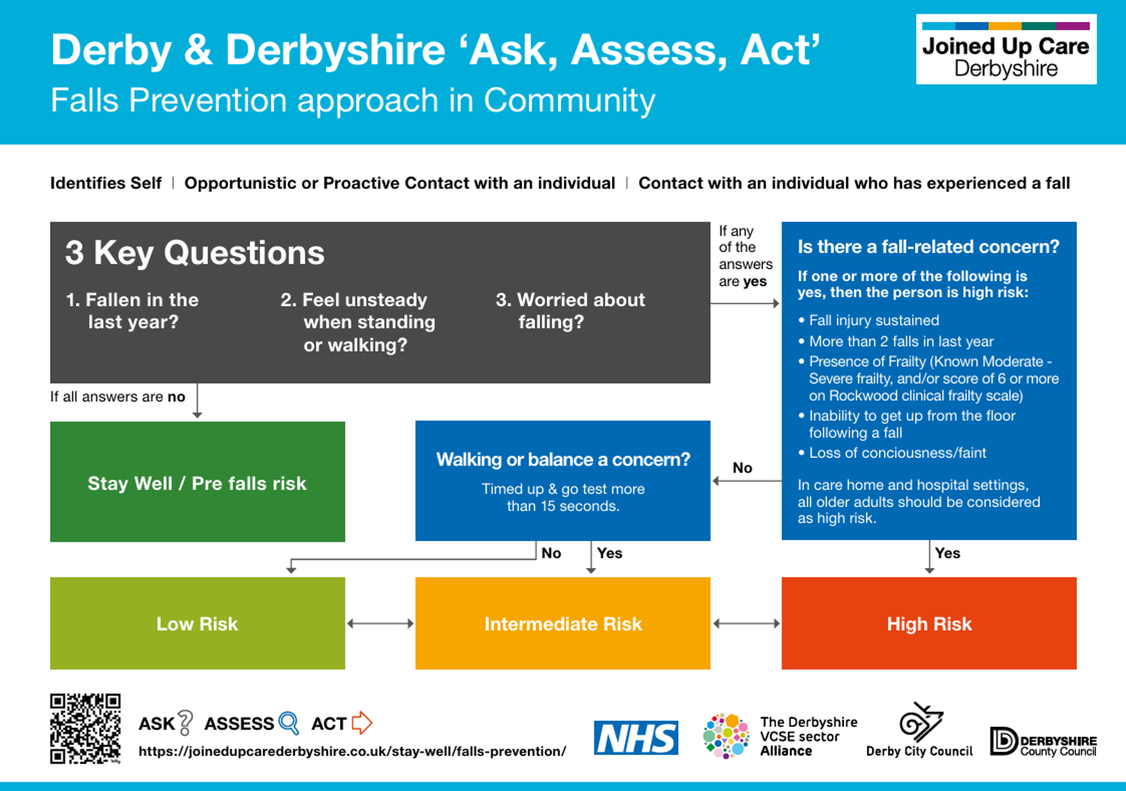
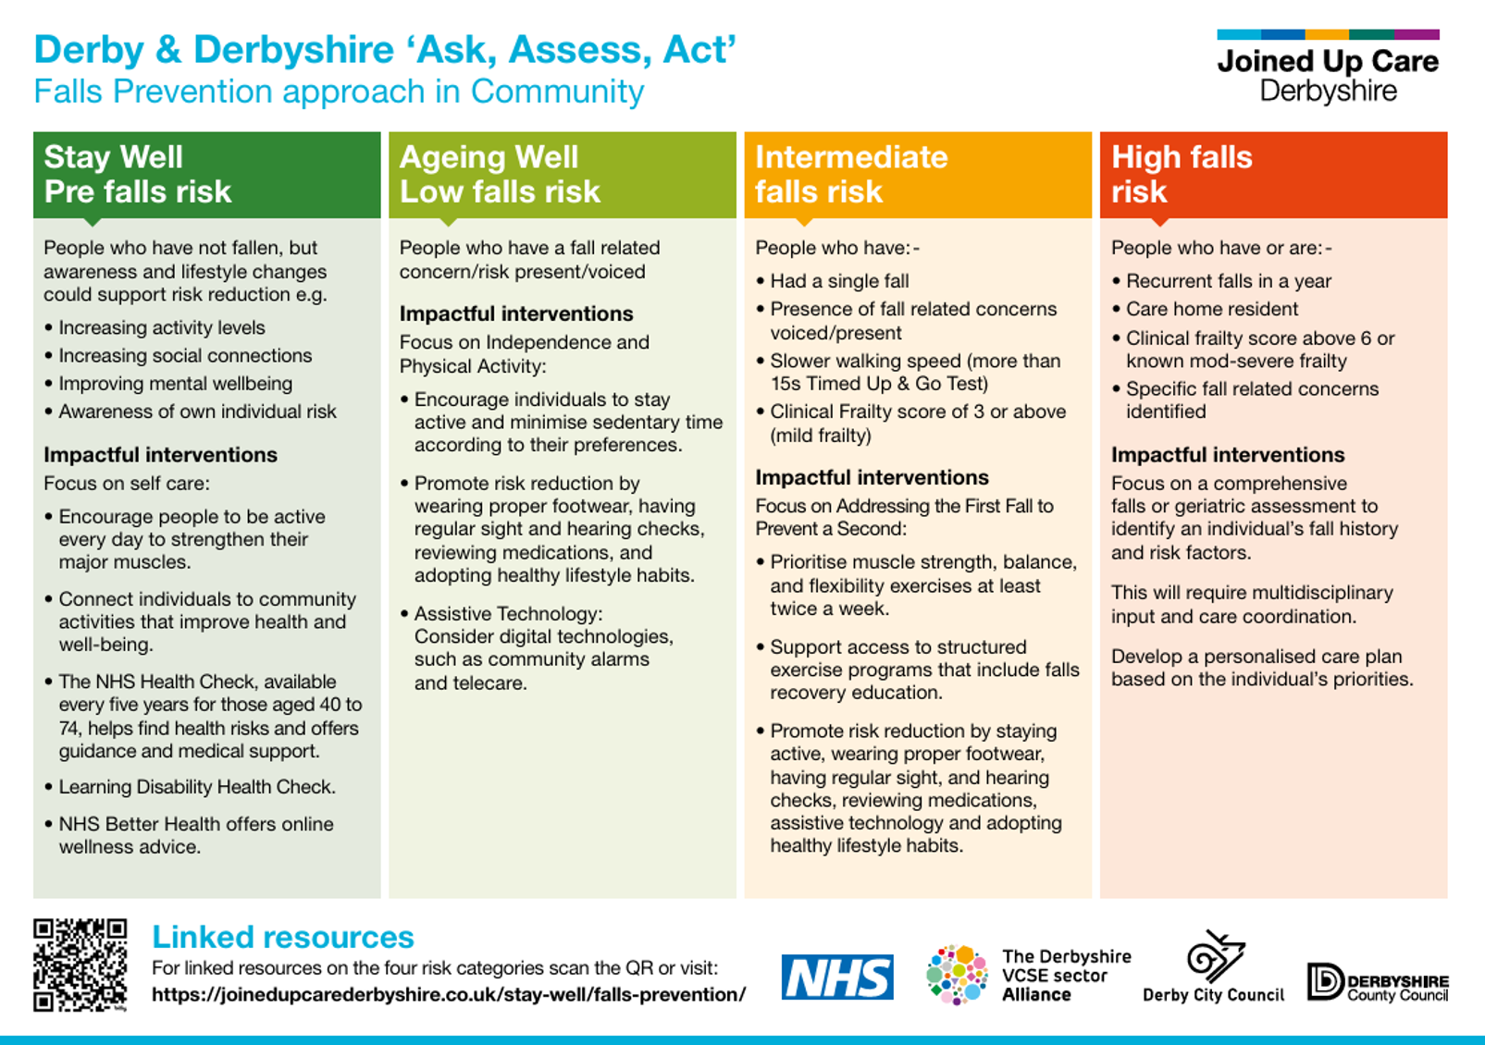
My Action Plan
You can use this action plan to record measures you want to take to reduce your risk of falling.
Description | Suggested Actions | Your Action and Notes
Be more active | Contact Live Stronger for Longer  email: fallsprevention@ageukderbyandderbyshire.org.uk  Age UK Derby & Derbyshire | Live Stronger for Longer
Review my alcohol levels. | The NHS recommended limits are 14 units a week, spread evenly throughout the week.  Alcohol and drugs support - Derbyshire County Council
Eat a healthy diet. | Contact Live Life Better Derbyshire for weight management support:  Telephone: 01629 538200  Free Phone: 0800 0852299  Email: llbd.info@derbyshire.gov.uk  Text: 80800  www.livelifebetterderbyshire.org.uk
Consider using a walking aid. | Contact GP, Occupational Therapist or Physiotherapist for an assessment.
My medications | Make sure you have regular medication reviews with your GP or Pharmacist.
My eyesight | Have regular eyesight tests – contact your local optician.  NHS Choices -  https://www.nhs.uk/live-well/healthy-body/look-after-your-eyes/  Or visit Sight impaired and severely sight impaired - Derbyshire County Council
My hearing | Be aware of any hearing loss and consult with GP.  Deaf, deafened and hearing loss - Derbyshire County Council
Safeguard my home | Check the home to ensure no loose carpets or rugs etc.  Adult care information sheets - Derbyshire County Council
My healthy feet | Check your slippers and shoes to make sure they fit well and if necessary contact https://www.ageuk.org.uk/services/in-your-area/foot-care/  Or use a local foot health practitioner or podiatrist (chiropodist)
Falls alarm service | Call Derbyshire telephone: 01629 533190.  Call Derbyshire - Derbyshire County Council
Technology Enabled Care – helping people live safe and independently at home | Call Derbyshire telephone: 01629 533190  Technology enabled care - Derbyshire County Council

