Derbyshire County Council

Equality and Diversity Strategy 2017 – 2021

Draft

Contents
- Introduction
- Context
- Our vision
- Priority areas for action
- Key principles
- Delivering our priorities
- Measuring success and reviewing progress
- Further information

- Introduction
Welcome to our latest strategy for equality and diversity covering the period 2017 to 2021. The strategy sets out:
- The challenges we face when seeking to improve the lives of local people who experience inequality or discrimination
- The values that will guide us in addressing challenges
- Our main priorities over the next four years
- How we will measure progress
The Council has a long history of tackling inequality and discrimination. Over this time our priorities have ensured that whatever the economic climate people in Derbyshire have access to employment, decent living standards and the high quality services which they need.
We take our responsibilities as an employer very seriously and have worked hard to ensure that our employees are supported and well trained to deliver the best possible services for local people.
Shrinking public sector resources will undoubtedly result in changes to the way in which we work. However, we will continue our work on equality and diversity, looking at new and different ways of working but always ensuring that the many and diverse communities of Derbyshire lie at the heart of how we work, the decisions we make, and the services we provide.
The Council remains highly committed to advancing equality, eradicating unfair treatment and promoting good relations across, and between, all our communities and this Strategy will act as the main vehicle to deliver our equality and diversity priorities moving forward.

- Context
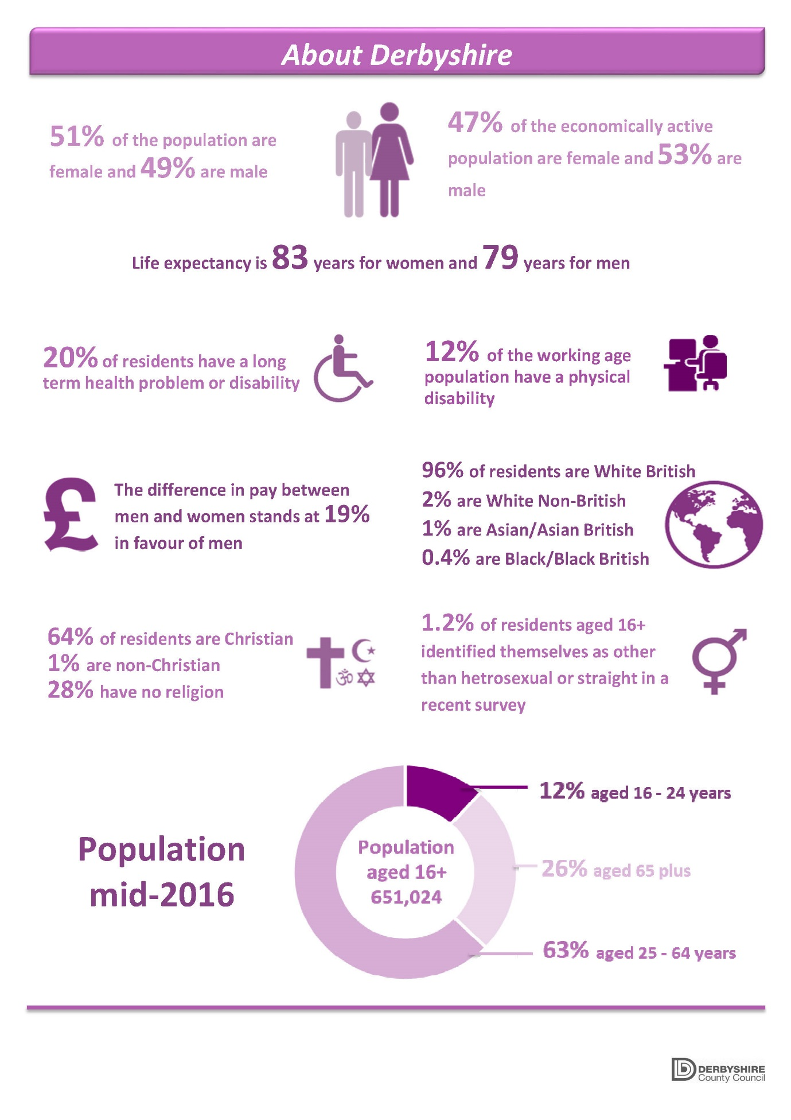
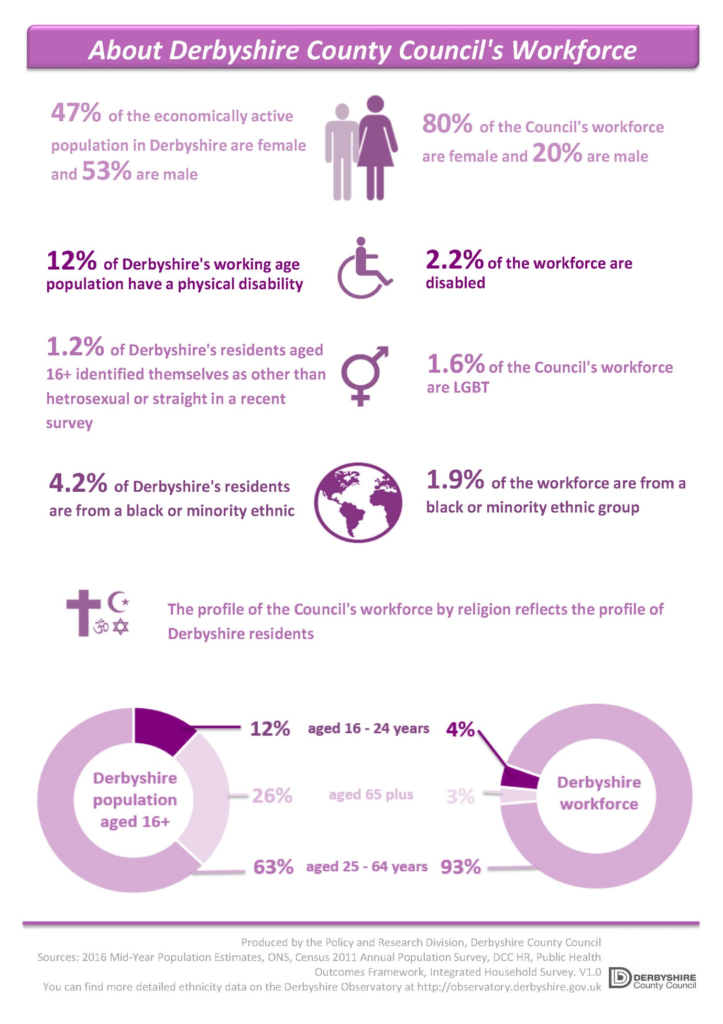

- Our vision
“A fair and inclusive Derbyshire, where all communities are strong places where equality and diversity are seen as positive aspects of everyday life, where individuals get on well together and feel included in the communities in which they live, work or study”
The vision will direct our work moving forward and sets the context for priority areas for action over the next four years.
- Priority areas for action
Our priority areas for action for 2017 – 2021 are:
- Fair and open decision-making
- Advancing equality of opportunity for disabled people
- Acknowledging and supporting carers
- Reducing rural isolation and improving access to services
- Creating safe communities for everyone
- Promoting and celebrating cultural diversity
- Improving health and well-being
- A skilled and diverse workforce
Priorities support the priorities and values set out in our new Council Plan – Working for Derbyshire, whilst building on the work that we have undertaken over previous years. Priorities also reflect the issues and challenges that we know exist across the diverse range of local communities in the county and where we know the Council could make further improvements.
- Key Principles
We recognise that we cannot change things on our own or deal with discrimination in isolation and that we have limited resources which need to be applied carefully and effectively. We also know that we can learn from those we serve and employ and that we need to support people to become confident and self-supporting. The following are therefore key principles that we will follow when delivering our priorities:
We will:
- Take equality and diversity into account when using, or deciding upon the deployment of limited resources
- Collaborate with partners and communities to tackle inequality, discrimination and harassment
- Listen to all our communities, taking full account of their needs and opinions, tackling those issues which result in inequality and discrimination
- Whenever possible, improve the range of opportunities available and support for people to be independent and resilient

- Delivering our priorities
To ensure that we work towards our vision and deliver identified priorities, we have developed the following action plan which sets out the key activity we will undertake.

Our action plan
Fair and open decision-making
Action | Lead responsibility | Timeframe | Progress measure
Ensure that EIAs are used to inform decisions about Council services and changes affecting the workforce | Departments | Ongoing | All major decisions about the delivery of services are informed by a comprehensive equality impact assessment  Significant restructures are subjected to an EIA to assess impact on groups of employees
Develop a corporate toolkit for carrying out an assessment of cumulative impact of service and budget decisions | Commissioning, Communities and Policy | 2017-18 | The Council is able to monitor the overall and cumulative impact of decisions at least annually, and this is being used to shape future decisions
Ensure that all protected characteristic groups can take part in consultation on proposals to change services and policies | Departments | Ongoing | Improved levels of participation amongst all protected characteristic groups
Advancing equality of opportunity for disabled people
Help implement the corporate strategy for people with autism | Diversity and Inclusion Board, Adult Care | 2017-18 | More employees have completed Autism Awareness training.  Improved access to employment for people with autism  Council services are sensitive to the needs of people with autism.
Help implement the corporate strategy for Disability Employment | Adult Care | 2017 – 21 | More disabled people are being assisted to gain employment and training, and to sustain existing employment.  Employers have a more positive approach towards employing people with disabilities.
Ensure that people with learning disabilities are involved in the co-design of social care and other services | Adult Care, Children’s Services | Ongoing | People with a learning disability are able to influence the design and delivery of social care services.
Continue to improve access to services, information and education for Deaf, hard of hearing and visually impaired people | Departments | Ongoing | Deaf and visually impaired people are influencing the design and delivery of Council services.  Deaf and hard of hearing children are receiving a better quality of education, receiving the support they need.  The use of BSL is being actively supported by the Council through its services and training.
Acknowledging and supporting carers
Seek to improve the levels and range of support which the Council offers to carers | Adult Care, Children’s Services | Ongoing | More carers are receiving advice and support from the Council.
Reducing rural isolation and improving access to services
Ensure that consideration is given within equality impact assessments to the needs of people in rural areas | Departments | From 2017 -18 | Wherever possible decisions about Council services support life in rural communities.
Sustain public and voluntary transport in rural areas | Economy, Environment & Transport | Ongoing | Public transport in rural areas is meeting the needs of people without their own forms of transport and helping to sustain life in rural communities.
Create safe communities for everyone
Continue to work with partners to respond effectively to domestic violence, hate crime and other forms of abuse or hatred | Commissioning, Communities & Policy | Ongoing | Improved reporting of incidents.  Victims receive the support they need.  There are active programmes to help perpetrators change their behaviour.  Over time individuals and communities feel safer.
Expand the number of safe places for people with learning disabilities | Commissioning, Communities & Policy; Adult Care | Ongoing | The numbers and type of venue used as Safe Places has increased.
Take appropriate action with partners to tackle cyber bullying and abuse, including where this is based on protected characteristics or cultural identity. | Children’s Services; Commissioning, Communities & Policy; Adult Care | Ongoing | Effective action is taken by appropriate agencies to respond to cyber abuse.  Awareness programmes are in place though schools and other means of contact with the public, employees and community organisations
Promoting and celebrating cultural diversity
Work with partners and communities to celebrate the contribution of our diverse communities | Diversity & Inclusion Board | Ongoing | Diversity calendar published  A range of events are celebrated and promoted by the Council, with partners, local people and organisations.
Use commissioning, procurement and the allocation of grant-aid to advance equality of opportunity, to reduce inequality and enhance relationships between diverse communities | Departments | Ongoing | There is clear evidence that the Council’s services which are delivered under procurement arrangements provide good and appropriate access for all parts of the community.
Continue work to improve awareness and access to services for LGBTQ people | Diversity and Inclusion Board | Ongoing | Improved local data is available on our LGBTQ community  Where appropriate, specific arrangements exist within services to target LGBTQ people and their needs
Develop the extent to which young peoples’ views of identity and diversity can shape our future approach to equality and diversity | Children’s Services | 2018 – 19 | Complete work with the Youth Council and other young people to understand the developing views of identity and diversity.  Use the findings to identify future work within the Council in relation to equality and diversity.
Improving health and well-being
Continue working to reduce the stigma around mental illness | Adult Care, Human Resources (within DCC) | Ongoing | More people have access to mental health awareness training and information.  Fewer hate crimes against people with a history mental illness.  People with a history of mental health problems are being supported into work and to retain employment.  Council services are responsive to changes in the types of support needed by people with a history of mental illness.
Further develop the use of Health Impact Assessments to help shape in decision-making and in helping to reduce health inequalities | Adult Care | Ongoing | Health Impact Assessments are helping to improve access to health services for disadvantaged or under-represented groups of people.
Improve access to health screening and health services for people from marginalised communities through health commissioning and health promotion campaigns | Adult Care | Ongoing | People from disadvantaged communities are able to access the health services, support and screening they need.
Improve access to and take-up of health and well-being advice and services by men | Adult Care | Ongoing | More men are attending screening services and seeking help earlier to avoid terminal and other serious illness.
A skilled and diverse workforce
Improve access to equality and diversity training for employees of the Council | Human Resources, Departments | Ongoing | Complete equalities training review.  Training available to meet the needs of the workforce.  Improved awareness of equality and diversity amongst employees, managers and partners/ suppliers.
Develop a Diversity Allies Scheme to support the implementation of this strategy | Diversity & Inclusion Board | 2017-18 | Programme launched in 201/2018.  After two years there are a group of effective allies who are helping to promote equality and diversity across the Council and more broadly.
Work to recruit and retain a skilled diverse workforce | Human Resources, Departments | Ongoing | Identify appropriate action to address under-representation within the workforce of any groups and to deal with occupational imbalances
Continue to develop and support opportunities for employees from diverse backgrounds to influence employment practices in the Council, including by supporting the role of the employee networks and employee panel | Human Resources, Departments | Ongoing | Employee sponsored diversity events are being held regularly  Policies and procedures are being updated in response to employee feedback and involvement including that of the Trade Unions, Employee Panel and Employee Networks
Publish statutory gender pay gap data, undertake equal pay audits and formulate action plan to address issues if necessary. | Human Resources, Departments | Annually in line with legal requirements | Gender pay gap data published and equal pay audit undertaken, issues identified and addressed where appropriate.
Maintain our Disability Confident Level 2 membership and consider progressing to Level 3, taking resourcing levels and cuts into account. | Human Resources, Departments | By 2019 | The Council is delivering the requirements of the Disability Confident Scheme and as a result disabled people are more represented within the Council’s workforce.
Adopt the Dying to Work Charter | Human Resources, Departments | 2018 | Charter adopted and policies being reviewed to meet commitments.

- Measuring success and reviewing progress
We will review progress against our priorities on a regular basis. In order to help assess our progress, we will monitor the following performance measures:
- EIAs completed are published and include analysis of the views and needs of diverse communities
- The number of disabled people helped into employment and training by the Council
- The number of carers supported by the Council
- User levels of public and community transport
- Satisfaction levels with Council services amongst people with learning disabilities, people with autism, Deaf people, LGBTQ people and people with a history of mental illness are being monitored and used to shape Council services
- A regular calendar of diverse events are celebrated across Derbyshire and within the Council
- Key indicators of health inequality are improving over time
- The proportion of younger, older, female, BME, Disabled and LGBT Council employees, including at senior levels of the organisation
- The number of employees undertaking equality and diversity based training
- The number of diversity allies recruited within the authority
- The mean and median gender pay gap in the Council.

The strategy and action plan will be reviewed annually and updated as necessary. A report, outlining the progress we are making will be published every two years.
- Further information
If you have any comments or feedback that you would like us to take into account in respect of this Strategy, or if you require a copy of this document in an alternative format, please contact the Policy and Research Division at policy@derbyshire.gov.uk or call 01629 538304.

